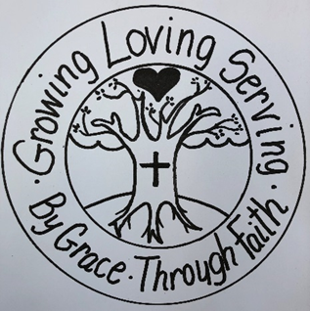
Grace Lutheran Church
6th and Main Streets
Royersford, PA 19468

610-948-3684
www.gracelutheranroyersford.com

The Rev. Janelle Krais, Pastor
Allison Wilcox, Deacon

Seventeenth Sunday After Pentecost
September 19, 2021
Worship Bulletin

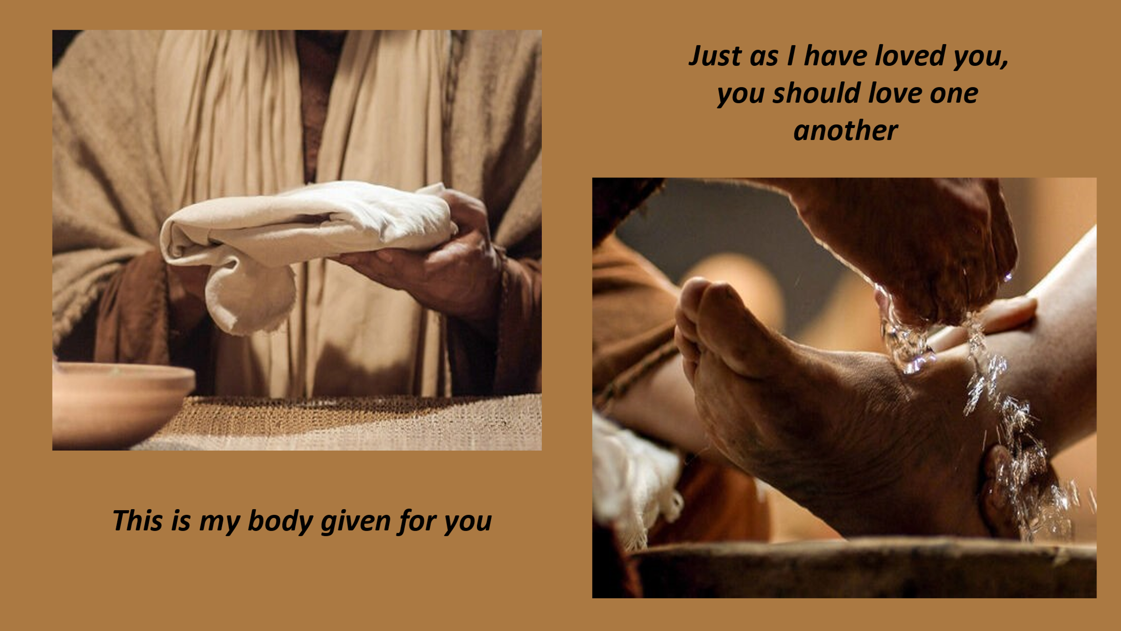

GREETING
L: Welcome to worship! Here at Grace, we are growing… loving… serving… by grace through faith!

L: We begin worship in the name of the Father, and of the Son, and of the Holy Spirit. C: Amen.

CONFESSION & FORGIVENESS
L: Let us prepare our hearts by confessing our sins… Almighty God, to whom all hearts are open, all desires known, and from whom no secrets are hid: Cleanse the thoughts of our hearts by the inspiration of your Holy Spirit that we may perfectly love you and worthily magnify your holy name, through Jesus Christ our Lord.
C: Amen.

L: Most merciful God,
C: We confess that we are in bondage to sin and cannot free ourselves. We have sinned against you in thought, word, and deed, by what we have done and by what we have left undone. We have not loved you with our whole heart; we have not loved our neighbors as ourselves. For the sake of your Son, Jesus Christ, have mercy on us. Forgive us, renew us, and lead us, so that we may delight in your will and walk in your ways to the glory of your holy name. Amen.

L: God, who is rich in mercy, loved us even when we were dead in sin, and made us alive together with Christ. By grace you have been saved. In the name of Jesus Christ, your sins are forgiven. Almighty God strengthen you with power through the Holy Spirit, that Christ may live in your hearts through faith +.
C: Amen.

SHARING OF THE PEACE
P: The peace of the Lord be with you. C: And, also with you.

PRAYER OF THE DAY
L: Almighty God, you allowed your Son, our Savior Jesus Christ, to take our flesh upon him and to suffer death on the cross.
Grant that we might share in his love and obedience to your will, and in the glorious victory of his resurrection; through your Son, Jesus Christ our Lord, who lives and reigns with you and the Holy Spirit, one God, now and forever. Amen.

SPECIAL MUSIC “Softly and Tenderly”
1 Softly and tenderly Jesus is calling,
calling for you and for me.
See, on the portals he's waiting and watching,
watching for you and for me.

Refrain
"Come home, (Come home,)
come home! (come home!)
You who are weary, come home."
Earnestly, tenderly, Jesus is calling,
calling, "O sinner, come home!"

2 Why should we tarry when Jesus is pleading,
pleading for you and for me?
Why should we linger and heed not his mercies,
mercies for you and for me? Refrain

3 Oh, for the wonderful love he has promised,
promised for you and for me!
Though we have sinned, he has mercy and pardon,
pardon for you and for me. Refrain

Text: Will L. Thompson, 1847-1909
CCLI License # 2023498

READING Luke 22:7-23
⁷Then came the day of Unleavened Bread, on which the Passover lamb had to be sacrificed. ⁸So Jesus sent Peter and John, saying, “Go and prepare the Passover meal for us that we may eat it.” ⁹They asked him, “Where do you want us to make preparations for it?” ¹⁰“Listen,” he said to them, “when you have entered the city, a man carrying a jar of water will meet you; follow him into the house he enters ¹¹and say to the owner of the house, ‘The teacher asks you, “Where is the guest room, where I may eat the Passover with my disciples?”’ ¹²He will show you a large room upstairs, already furnished. Make preparations for us there.” ¹³So they went and found everything as he had told them; and they prepared the Passover meal. ¹⁴When the hour came, he took his place at the table, and the apostles with him. ¹⁵He said to them, “I have eagerly desired to eat this Passover with you before I suffer; ¹⁶for I tell you, I will not eat it until it is fulfilled in the kingdom of God.” ¹⁷Then he took a cup, and after giving thanks he said, “Take this and divide it among yourselves; ¹⁸for I tell you that from now on I will not drink of the fruit of the vine until the kingdom of God comes.” ¹⁹Then he took a loaf of bread, and when he had given thanks, he broke it and gave it to them, saying, “This is my body, which is given for you. Do this in remembrance of me.” ²⁰And he did the same with the cup after supper, saying, “This cup that is poured out for you is the new covenant in my blood.

²¹But see, the one who betrays me is with me, and his hand is on the table. ²²For the Son of Man is going as it has been determined, but woe to that one by whom he is betrayed!” ²³Then they began to ask one another, which one of them it could be who would do this.

SERMON “Last Supper” Deacon Allison
I’m probably not unlike many of you as far as holy communion goes. I received my first communion when I was in fourth grade. Even though my memory isn’t what it used to be, I still remember the bright lavender skirt I wore for the occasion!
After that, I went through confirmation where I learned the theology and doctrine of communion in the Lutheran Church. I read – and had to memorize - Luther’s Small Catechism on the subject: “What is the Sacrament of the Altar? It is the true body and blood of our Lord Jesus Christ under the bread and wine, instituted by Christ himself for us Christians to eat and to drink.”
There has been a lot of conversation – debate even – about Luther’s understanding of communion over the last 500 years, and in Seminary, I wrote papers about it and learned how to teach it myself when I became a Confirmation teacher and then Deacon in the ELCA.
So, I know and understand the dogma of communion. I can explain to you – if ever you so desire – what it means that Jesus is present in our communion: what Luther means by the true body and blood of Christ being under the bread and wine.
But when the gospel writers wrote their accounts about the Last Supper – I don’t think doctrine was on their mind. In fact, if you go by John’s account, bread, wine, body and blood weren’t on his mind either.
And during supper Jesus, knowing that the Father had given all things into his hands, and that he had come from God and was going to God, got up from the table, took off his outer robe, and tied a towel around himself. Then he poured water into a basin and began to wash the disciples’ feet and to wipe them with the towel that was tied around him. He came to Simon Peter, who said to him, “Lord, are you going to wash my feet?” Jesus answered, “You do not know now what I am doing, but later you will understand.” Peter said to him, “You will never wash my feet.” Jesus answered, “Unless I wash you, you have no share with me.” Simon Peter said to him, “Lord, not my feet only but also my hands and my head!” Jesus said to him, “One who has bathed does not need to wash, except for the feet, but is entirely clean. And you are clean, though not all of you.”

Little children, I am with you only a little longer. You will look for me; and as I said to the Jews so now, I say to you, ‘Where I am going, you cannot come.’ I give you a new commandment, that you love one another. Just as I have loved you, you also should love one another. By this everyone will know that you are my disciples, if you have love for one another.”

John’s reading is the one we get on Maundy Thursday – Maundy coming from the Latin word meaning “mandate.” For John, the Last Supper is about that mandate. “Just as I have loved you, you should love one another.”
So, as I’ve said in probably at least half of the sermons I’ve ever preached, it all comes down to relationship. It jumps right off the page in John’s gospel, but even in Luke, relationship is the cornerstone.
As the disciples and Jesus sit down to their Passover meal, Jesus tells them that he has “eagerly desired” to eat this meal with them. Some translations say that he longed for it or that he passionately desired it.
As the end drew near for Jesus, what was important for him? A last meal with the disciples who had been by his followers, his family, his friends, his fellow sojourners. And as he gave the words of the blessing – as he broke the bread and poured the wine – what are the words that ring out?
This is my body given FOR YOU. This is my blood shed FOR YOU. A pastor I had once, always emphasized the FOR YOU every time he handed out the wafer or poured the wine. There was never a doubt as to who it was for.
Even if we aren’t able to explain Luther’s definition of true presence, many of us still experience it. We know that feeling that the body and blood of Christ bring to us. We know the connection we feel. We know there is something sacred – something holy - that happens in the communion. Something sacramental.
Holy Communion is indeed one of our two sacraments. For Lutherans, a sacrament is defined as a rite which has the command of God to which the promise of grace has been added. So, yeah, Holy Communion (and also baptism). Then, through the Last Supper meal, we find out that relationship between God and God’s people is sacramental in and of itself.
That relationship began with God’s claim on the Israelites. For the Jewish people, the Passover holiday is one that celebrates the relationship between God and God’s people. In Luke, as well as Mark and Matthew, the Last Supper meal takes place during that Passover celebration. In John, it takes place just before it.
With this new covenant – the one which Jesus claims in Luke – our relationship with God is taken to a new level. Our relationship with God is holy and sacred. Holy Communion. Sacred Relationship. A relationship that is built on love.
We can hear in his words, the love Jesus has for his disciples. There is an intimacy in this Last Supper. There is love in this Last Supper – love even for one who would betray and one who would deny.
But John reminds us in his gospel that that sacred relationship isn’t just between God and us. It is also between all of us with each other. “Just as I have loved you, you also should love one another.”
That’s not a suggestion from Jesus. He tells us it is a commandment. It’s a commandment that sounds so simple that even a child could understand it. But one that over and over again we can’t quite seem to live up to. It’s one that we struggle with time and time again.
“Just as I have loved you, you also should love one another.” Love like Jesus loved. Love sacrificially. Love intentionally. Love wholly. Love like Jesus puts the needs of others before our own. Love like Jesus serves. Love like Jesus is radical and overpowering. It is deep and compassionate. “And they will know we are Christians by our love…” the song goes.
I don’t know about you, but the kind of love Jesus is calling us to is both awe-inspiring and pressure inducing. Because the kind of love that we show the world is the love by which we will be judged by the world. It’s the kind of love that tells the world who we believe God to be.
It’s the kind of love that has the power to say: “God is a God of relationship, of the sacred, of compassion, of grace.” Without that kind of love – that is sacrificial, radical - we can end up telling the world that God’s love is conditional and exclusionary. “Just as I have loved you, you also should love one another.”
Luke tells us that at the Last Supper, Jesus loved by sharing a meal with those who would let him down. Jesus loved by sharing himself and making a new covenant with those who would let him down. And John tells us that Jesus loved by getting down on his knees and washing the feet of even the one who would betray him and the one who would deny him. There were no shortcuts in the love of Jesus. No exclusions.
Holy Communion is the time where that Last Supper comes alive for us. It is holy and is sacred. It is communal. And love is its binding – the binding of the sacramental relationship between God and God’s people. And the binding in the sacramental relationship God’s people are meant to have with the world. “Just as I have loved you, you also should love one another.”

APOSTLES’ CREED
I believe in God, the Father almighty, creator of heaven and earth.

I believe in Jesus Christ, his only Son, our Lord.
He was conceived by the power of the Holy Spirit and born of the virgin Mary.
He suffered under Pontius Pilate, was crucified, died, and was buried.
He descended into hell.
On the third day he rose again.
He ascended into heaven and is seated at the right hand of the Father.
He will come again to judge the living and the dead.
I believe in the Holy Spirit, the holy catholic Church, the communion of saints,
the forgiveness of sins, the resurrection of the body, and the life everlasting. Amen

PRAYERS & LORD’S PRAYER
L: Made children and heirs of God’s promise, we pray for the church, the world, and all in need.

A brief silence.

L: God of community, we pray for the church around the world. Unite us in our love for you. Help us overcome our divisions, that we are encouraged to work together for your sake. Lord, in your mercy, C: hear our prayer.

L: God of creation, we pray for this hurting earth. Awaken in us a new desire to care for this world and empower us to support agencies, organizations, and individual efforts to heal our environment. Lord, in your mercy,
C: hear our prayer.

L: God of cooperation, we pray for nations of the world embroiled in conflict (especially). Inspire leaders to listen to each other and work towards peaceful solutions to disagreements. Protect the vulnerable, especially children, who cannot find safety in their home or country. Lord, in your mercy,
C: hear our prayer.

L: God of comfort, we pray for all who live with mental or physical illness. Help them find appropriate care. Bring healing and wholeness when the path forward seems bleak. Lord, in your mercy, C: hear our prayer.

L: God of compassion, we pray for the young people of this congregation. Renew in us your call to welcome the children in our midst. As they grow, strengthen their faith and our commitment to them. Lord, in your mercy,
C: hear our prayer.

L: God of consolation, we give you thanks for our loved ones who have died and pray for all who grieve today (especially). Shine your grace on all your saints. Lord, in your mercy, C: hear our prayer.

L: Receive these prayers, O God, and those in our hearts known only to you; through Jesus Christ our Lord. C: Amen.

LORD’S PRAYER
C: Our Father, who art in heaven, hallowed be thy name,
thy kingdom come, thy will be done, on earth as it is in heaven.
Give us this day our daily bread,
and forgive us our trespasses, as we forgive those, who trespass against us,
and lead us not into temptation, but deliver us from evil.
For thine is the kingdom, and the power, and the glory,
forever and ever. Amen.

COMMUNION
P: Christ has prepared the feast. Eat, drink and be blessed by this gift of life.

P: In the night in which he was betrayed, our Lord Jesus took bread, and gave thanks; broke it and gave it to his disciples saying: “Take and eat; this is my body, given for you. Do this for the remembrance of me”. (all consume wafers)

P: Again, after supper, he took the cup, gave thanks, and gave it for all to drink, saying: “This cup is the new covenant in my blood, shed for you and for all people for the forgiveness of sins. Do this for the remembrance of me”.
(all consume grape juice)

P: Let us pray… We give you thanks, almighty God, that you have refreshed us through the healing power of this gift of life; and we pray that in your mercy you would strengthen us, through this gift, in faith toward you and in fervent love toward one another; for the sake of Jesus Christ our Lord. C: Amen

BENEDICTION
P: The Lord bless you and keep you. The Lord make his face shine upon you and be gracious to you. The Lord look upon you with favor and give you peace. +. C: Amen.

MUSIC “Stand Up, Stand Up, For Jesus”
1 Stand up, stand up for Jesus,
as soldiers of the cross,
lift high his royal banner;
it must not suffer loss.
From vict’ry unto vict’ry
his army he shall lead,
till ev’ry foe is vanquished
and Christ is Lord indeed.
2 Stand up, stand up for Jesus;
the trumpet call obey;
stand forth in mighty conflict
in this his glorious day.
Let all his faithful serve him
against unnumbered foes;
let courage rise with danger,
and strength to strength oppose.

3 Stand up, stand up for Jesus,
stand in his strength alone;
the arm of flesh will fail you,
you dare not trust your own.
Put on the gospel armor;
each piece put on with prayer.
Where duty calls or danger,
be never wanting there.

4 Stand up, stand up for Jesus,
the strife will not be long;
this day the din of battle,
the next the victor’s song.
The soldiers, overcoming,
their crown of life shall see,
and with the King of glory
shall reign eternally.

Text: George Duffield, 1818-1888, alt.
CCLI License # 2023498

DISMISSAL
L: Go in peace. Serve the Lord.
C: Thanks be to God.

